Problem Statement
Automations & Multi-Agent Systems — Problem Statement
Background
Planning a trip sounds simple at first, but in practice it quickly becomes overwhelming.
A tra“Plan a 5-day trip to Japan. Tokyo + Kyoto. $3,000 budget. Love food and temples, hate crowds.”
veler may have a request like:
To fulfill that well, we need to combine many different kinds of work:
- Understanding the traveler’s goals
- Researching destinations and attractions
- Comparing hotels and transport options
- Staying within budget
- Checking whether the final itinerary actually matches the request

Objective
Design a simple Travel Planning Multi-Agent System that can automatically turn a short travel request into a useful trip plan.
The goal is not to build a perfect travel product, but to show how multiple specialized AI agents can work together on a real-world problem that product managers can easily understand.

Real-World Problem to Solve
"AI Travel Planner"
A user gives a natural-language travel request such as:
Plan a 5-day trip to Japan. Tokyo + Kyoto. $3,000 budget. Love food and temples, hate crowds.
The system should produce:
- A day-by-day trip outline
- Suggested neighborhoods / areas to stay
- Travel logistics between cities
- Budget-friendly recommendations
- A final itinerary that respects the user’s preferences and constraints

Multi-Agent System Design
1. Orchestrator Agent
Role: Creates the master plan, assigns work, and combines outputs into the final itinerary.
What it does:
- Reads the user request
- Extracts key constraints:
  - Destination: Japan
  - Duration: 5 days
  - Cities: Tokyo + Kyoto
  - Budget: $3,000
  - Preferences: food, temples
  - Avoidances: crowds
- Delegates tasks to the other agents
- Synthesizes the final travel plan

2. Destination Research Agent
Role: Finds the best places, experiences, and food ideas based on the traveler’s preferences.
Possible inputs:
- Web search
- Travel guides
- Restaurant reviews
- Attraction summaries
What it does:
- Recommends neighborhoods, temples, food streets, and local experiences
- Suggests less-crowded options where possible
- Identifies “must-do” vs “nice-to-have” items
Example output:
- Best quiet temple areas in Kyoto
- Food neighborhoods in Tokyo
- Off-peak or less-crowded experiences

3. Logistics Agent
Role: Handles the practical side of moving and staying.
Possible inputs:
- Hotel APIs or sample hotel data
- Train routes / transit info
- Maps / distance tools
What it does:
- Suggests where to stay in each city
- Estimates travel time between locations
- Recommends how to move from Tokyo to Kyoto
- Builds a realistic sequence for each day
Example output:
- 2 nights in Tokyo, 2 nights in Kyoto, 1 flexible day
- Shinkansen between cities
- Day plans that reduce backtracking

4. Budget Agent
Role: Ensures the plan stays within budget.
Possible inputs:
- Currency conversion
- Estimated hotel costs
- Food and transport price ranges
- Attraction pricing
What it does:
- Breaks the budget into categories:
  - Stay
  - Transport
  - Food
  - Activities
- Flags when the plan becomes too expensive
- Suggests cheaper alternatives
Example output:
- Estimated total spend: $2,650
- Hotel cost too high in central Tokyo → suggest alternate area

5. Review Agent
Role: Validates the final itinerary before it is shown to the user.
What it checks:
- Does the itinerary fit into 5 days?
- Does it include both Tokyo and Kyoto?
- Is it within the $3,000 budget?
- Does it align with “food + temples”?
- Does it try to avoid crowded experiences?
- Is the plan realistic from a travel-time perspective?
This agent acts like a quality checker before the result is delivered.
Orchestrator -> [Destination, Logistics, Budget in parallel] -> Review

Optional → VOICE AGENT
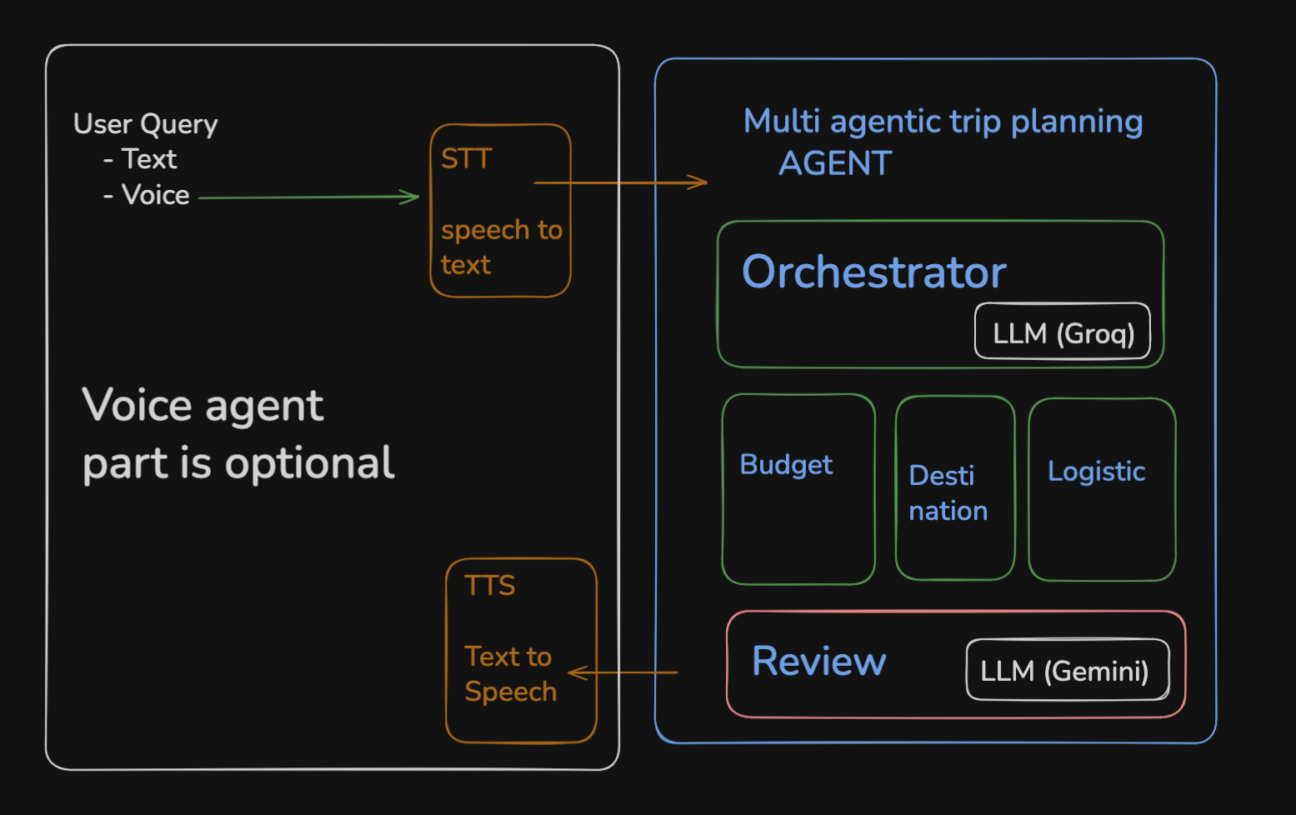

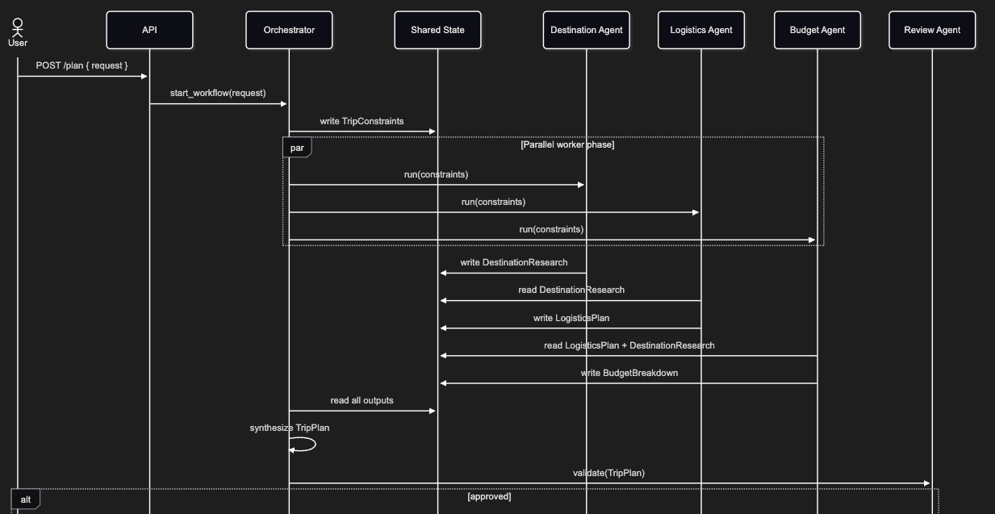

Prompts
- Create a problemStatement.md file that stores complete context of @problemStatement.txt
Currently we will build this for Dubai location only
- Generate a detailed architecture.md for building this multi-agentic project using @docs/problemStatement.md
- Generate a phase-wise implementation-plan.md using @docs/architecture.md and @docs/problemStatement.md
- Orchestrator, Budget, Logistics and Destination agent can use Groq as LLM and review agent it can use Gemini as LLM
https://en.wikivoyage.org/wiki/Dubai#Budget rather the mock data we can use data from this website
Update these in the @docs/implementation-plan.md
- For review we can use a better gemini model, update that in the @docs/implementation-plan.md

- Implement phase1 as per the @docs/implementation-plan.md
- Implement phase2 as per the @docs/implementation-plan.md
- For review agent we can use this model - Gemini 2.5 Flash
Request per minute - 5
Tokens per minute - 250K
Request per day - 20
llama-3.3-70b-versatile
request per minute - 30
request per day - 1K
Tokens per minute - 12K
Tokens per day - 100K
These are the limits on the models we are having so update phase2
- Implement phase3 as per the @docs/implementation-plan.md
- Implement phase4 as per the @docs/implementation-plan.md

